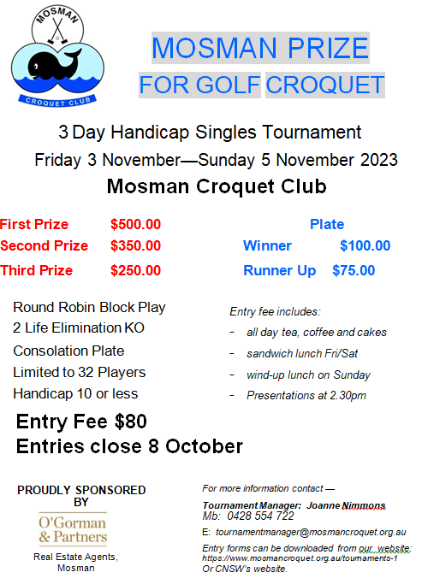

ENTRY FORM
The Mosman Prize, 3-5 November 2023

Handicap Singles Golf Croquet
Entries close: 2 October 2023
Name:
Address:
Postcode:
Telephone: Mobile:
Email:
Club: AHS Handicap:
Payment (Entry Fee $80.00)
Entry fee includes: all day tea/coffee, sandwich lunch Fri/Sat, after play refreshments, Lunch on Sunday.

Visitors welcome at BBQ lunch. Cost $25.00.

I am (also) paying $_____________ for ______________ friends/spectators at $25 per person for the Lunch on Sunday.

1. On-line:  Pay direct to Mosman Croquet Club at  Bendigo Bank Mosman  BSB 633-000 Account No. 146453774  Reference: Prize “your name”  Send a copy of this form by email to tournamentmanager@mosmancroquet.org.au | 2. By post:  Send this form with your cheque to:  Tournament Manager,  The Mosman Prize  Mosman Croquet Club,  2D Alexander Ave, MOSMAN, 2088
Copies of this form can be downloaded from our website, http://www.mosmancroquet.org.au/
Are you willing to referee? Yes/No

