Instructions: On-line Booking System –for DOUBLES or SINGLES
For FIRST TIME Booking:
- On Mosman Croquet Club website HomePage, click the . BOOKING SYSTEM. Button
Read the “Playing Conditions during CoronaVirus” page.
If you agree to comply with these Conditions, click the link (HERE) to go to the Mosman Croquet Booking System:
- Select the DATE you want, using the ">" arrow beside today's date at the top of the page.
To change to next month, use ">>" arrow beside the calendar month heading
- Check availability for the time you want to book, and which Lawns are available.
Select a start time: 9:00am, 11:00am, 1:00pm, or 3:00pm - on your Lawn of choice.
- Click on the green Book box, at top of page, above the lawn booking times
- Enter your usual email address and click NEXT. This brings up the NEW BOOKING window.
- Adjust your finish time, to cover a 2 hour period, finishing at 11am, 1pm, 3pm, or 5pm.
In the “BOOKING TITLE” space enter either “SINGLES” if you are booking for two players, or “DOUBLES” if booking for 4.
- Complete the required (*) details eg your First and Last Names and telephone number.
- Check box to accept the booking system's Terms and Privacy Policy.
Click Confirm Booking box.
Then go to another date and make a new booking, OR close the Tab.
MAXIMUM 2 bookings per member, per week
REGISTER your details, following your first booking:
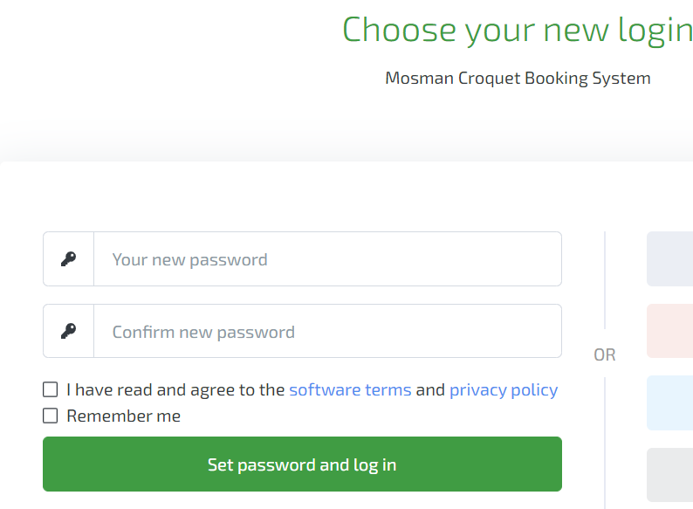
You will receive an email “Confirm your new account”, from the Mosman Croquet Booking System
Click on Confirm Account and Setup your Login
Provide a simple easy password
(must include 1 uppercase letter and 1 number)
and complete the details on this page
When you “Set password, and Login” this will take you into the Booking System again.

For Booking, once Registered for Mosman Croquet Booking System:
- On Mosman Croquet Club website HomePage, click the . BOOKING SYSTEM. Button
From the “Playing Conditions” page, click the link (HERE) to go to the Booking System:
- Select the DATE you want, using the ">" arrow beside today's date at the top of the page.
To change to next month, use ">>" arrow beside the calendar month heading
- Check availability for the time you want to book, and which Lawns are available.
Select a start time: 9:00am, 11:00am, 1:00pm, or 3:00pm - on your Lawn of choice.
- Click on the green Book box, at top of page, above the lawn booking times
- Enter your email address (and Login window password, if requested) & click NEXT.
This brings up the NEW BOOKING window.
- Adjust your finish time, to cover a 2 hour period.
In the “BOOKING TITLE” space enter either “SINGLES” if you are booking for two players, or “DOUBLES” if booking for 4.
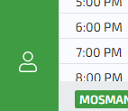
- Click Confirm Booking box.
Then go to another date and make a new booking,
OR Log Out in bottom left hand corner
and close the Tab.
NOTE: If you have problems logging in, because of your password –click on the Reset my password text, and the RESET email will go to your usual email address to enable you to set your preferred password.

If having trouble with the Booking System call:
- Anthea Piddington: 0401 070 855
- Fidye Westgarth: 0419 703 050
- Penny Paterson: 0409 848 309

Are you looking for a Partner?
If you would love a game and are unsure who to call, click the box .NEED A PARTNER . (on the Home Page beneath BOOKING SYSTEM )
- You can look for someone to phone, to join you for your preferred time
and / or
- You can register your details at Add Name stating which times you would like to play.
NOTE: To access this information, you must be logged in as a Member on the MCC Website

