Wafer Cannons by Neil Hardie

How to get a cannon
If, after you make a roquet, the croquet ball finishes in contact with another ball, this is a cannon. It usually happens on the boundary when the croquet ball is measured in, and there is another ball on the boundary line which interferes with the placement of the croquet ball. It is especially common at corners. Beginners are usually frightened of cannons, while good players aim to get them wherever possible.

Rules for cannons
With a cannon, both the striker ball and the third ball become ‘balls in hand’ and can be moved. You can place the striker ball and the other ball anywhere in contact with the croquet ball, but not in contact with each other. The croquet ball may not be moved (once it has been measured in).

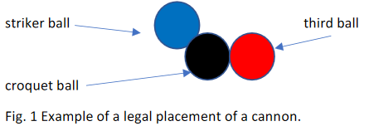

If you get a cannon
For advanced players, getting a cannon is an opportunity to place two balls in advantageous positions. For beginners, the main aim is to rush the third ball to a good position.

Wafer cannons
In a wafer cannon, the striker’s ball is placed as close as possible to the third ball while in contact with the croquet ball. In Fig 2 there is a very small gap between blue (the striker’s ball) and red (the third ball).

There are now many options for the player: she may just rush the red to a good position leaving black where it is, or she may rush red and also move black to a more useful position. Provided the wafer (distance between the blue and red ball) is thin enough, the red will be sent along the line of centres.

To get a simple rush without moving black much, you fine take-off from croquet ball as shown in Fig 3. Note that you do not aim along the line of centres of blue and red –this would move the black considerably, and is more difficult to control. You need to hit harder than in a simple rush, as the striker’s ball moves some distance, so you are moving two balls.

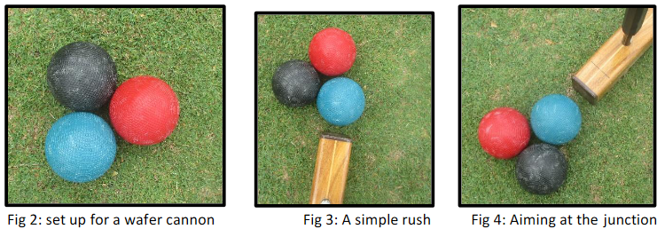

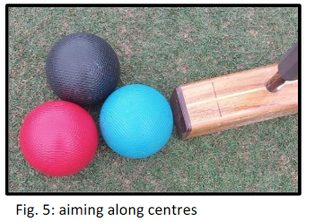
If you aim at the contact point between the black and red(Fig. 4), both balls move a long way: black (the croquet ball) goes about twice the distance of the red (the roqueted ball). You have to remember to hit blue harder as you are moving three balls.

Another option is shown in Fig 5 –aiming along the line of centres of blue and red. In this case the croquet ball (black) goes about half the distance of the roqueted ball (red).

We would recommend that players experiment with wafer cannons, trying different angles and seeing where the balls go. It is another option to the more common banana cannon.

